Lab Copy — Django Setup & Simple App (blog_users)
Name: Sagar Maity
Roll No.: 120
Date: 30.11.25
Experiment: Install Django, create project & app, templates, static files, model, migrate, display data.

Objective
Install Django in a virtual environment, create a project and app, render templates and static files, create a model, add data, and display it.

Environment / Tools
- OS: Windows.
- Python ≥ 3.x, pip, venv.

1. Create virtual environment
- cd C:\path\to\workfolder
- python -m venv myworld
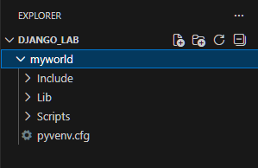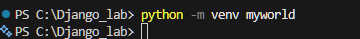
Explorer or dir showing myworld folder.

2. Activate environment
- PowerShell:
- myworld\Scripts\Activate.ps1
After activation prompt becomes: (myworld) C:\path\to\workfolder\>
Terminal after activation.
PowerShell note (if blocked):
Set-ExecutionPolicy -ExecutionPolicy RemoteSigned -Scope CurrentUser
(only if allowed).

3. Install Django
(myworld)
- python -m pip install Django

4. Check Django version
(myworld)
- django-admin --version
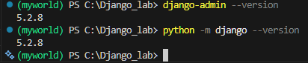
Django version in terminal.

5. Create Django project
(myworld)
- django-admin startproject my_blog
- cd my_blog
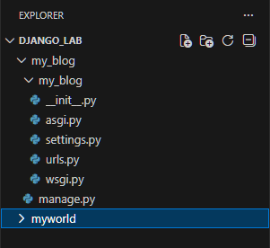
Folder tree showing manage.py and my_blog/.

6. Create app blog_users
(myworld)
- python manage.py startapp blog_users
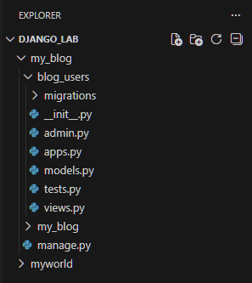
blog_users/ folder structure (with migrations/, views.py, etc.).

7. Run server (test)
(myworld)
- python manage.py runserver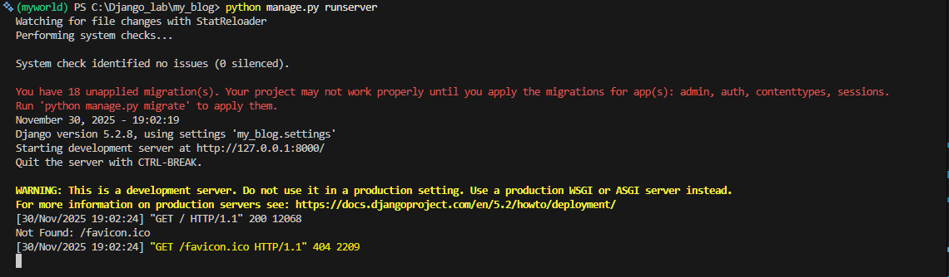
Open: http://127.0.0.1:8000/ in browser. 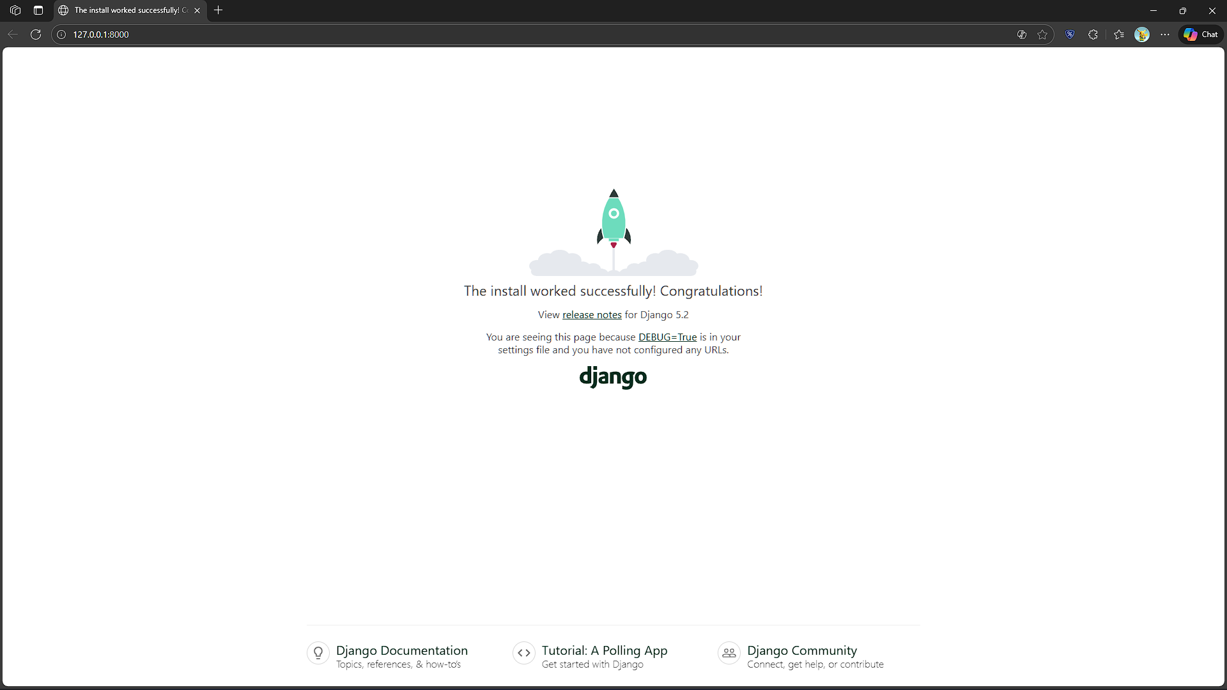.
Browser showing Django default page or terminal showing server started.
Stop server with Ctrl+C to continue.

Files to create / edit — exact code

A — blog_users/views.py

from django.http import HttpResponse
from django.template import loader
from .models import Bloguser
def blog_users(request):
return HttpResponse("Hello world!")
def members(request):
myusers = Bloguser.objects.all().values()
template = loader.get_template('all_users.html')
context = {'myusers': myusers}
return HttpResponse(template.render(context, request))
(One view for test, one to show DB data.)

B — create blog_users/urls.py

from django.urls import path
from . import views
urlpatterns = [
path('blog-users/', views.blog_users, name='blog-users'),
path('all-users/', views.members, name='all-users'),
]

C — edit project urls my_blog/urls.py
from django.contrib import admin
from django.urls import include, path
urlpatterns = [
path('', include('blog_users.urls')),
path('admin/', admin.site.urls),
]
(Registers app routes.)

D — blog_users/templates/myfirst.html

{% load static %}

<!DOCTYPE html>

<html lang="en">

<head>

<meta charset="utf-8">

<title>My First Django</title>

<!-- Bootstrap CSS -->

<link

href="https://cdn.jsdelivr.net/npm/bootstrap@5.3.3/dist/css/bootstrap.min.css"

rel="stylesheet"

integrity="sha384-QWTKZyjpPEjISv5WaRU9OFeRpok6YctnYmDr5pNlyT2bRjXh0JMhjY6hW+ALEwIH"

crossorigin="anonymous">

<!-- Your static CSS -->

<link rel="stylesheet" href="{% static 'myfirst.css' %}">

</head>

<body class="bg-light">

<div class="container py-5">

<div class="card shadow-lg p-4">

<h1 class="text-center text-primary">Hello World!</h1>

<p class="text-center fs-4">Welcome to my first Django project!</p>

</div>

</div>

<!-- Bootstrap JavaScript -->

<script

src="https://cdn.jsdelivr.net/npm/bootstrap@5.3.3/dist/js/bootstrap.bundle.min.js"

integrity="sha384-YvpcrYf0tY3lHB60NNkmXc5s9fDVZLESaAA55NDzOxhy9GkcIdslK1eN7N6jIeHz"

crossorigin="anonymous"></script>

</body>

</html>

E — blog_users/templates/all_users.html
<!DOCTYPE html>
<html lang="en">
<head>
<meta charset="UTF-8">
<title>Blog Users</title>

<!-- Bootstrap CSS -->
<link
href="https://cdn.jsdelivr.net/npm/bootstrap@5.3.3/dist/css/bootstrap.min.css"
rel="stylesheet"
integrity="sha384-QWTKZyjpPEjISv5WaRU9OFeRpok6YctnYmDr5pNlyT2bRjXh0JMhjY6hW+ALEwIH"
crossorigin="anonymous">
</head>

<body class="bg-light">

<div class="container py-5">
<div class="card shadow-lg">
<div class="card-header bg-primary text-white text-center">
<h2>Blog Users</h2>
</div>

<div class="card-body">
<ul class="list-group">
{% for x in myusers %}
<li class="list-group-item fs-5">
{{ x.firstname }} {{ x.lastname }}
</li>
{% empty %}
<li class="list-group-item text-danger">No users found.</li>
{% endfor %}
</ul>
</div>
</div>
</div>

<!-- Bootstrap JS -->
<script
src="https://cdn.jsdelivr.net/npm/bootstrap@5.3.3/dist/js/bootstrap.bundle.min.js"
integrity="sha384-YvpcrYf0tY3lHB60NNkmXc5s9fDVZLESaAA55NDzOxhy9GkcIdslK1eN7N6jIeHz"
crossorigin="anonymous">
</script>

</body>
</html>

F — blog_users/static/myfirst.css
body {
background-color: lightblue;
font-family: verdana;
}

G — blog_users/models.py

from django.db import models
class Bloguser(models.Model):
firstname = models.CharField(max_length=255)
lastname = models.CharField(max_length=255)
def __str__(self):
return f"{self.firstname} {self.lastname}"

H — register app in my_blog/settings.py (add in INSTALLED_APPS)

INSTALLED_APPS = [
'django.contrib.admin',
'django.contrib.auth',
'django.contrib.contenttypes',
'django.contrib.sessions',
'django.contrib.messages',
'django.contrib.staticfiles',
'blog_users', # <-- add this
]
(Then save.)

Database: migrations & add data
- Make migrations:
(myworld)
- python manage.py makemigrations blog_users
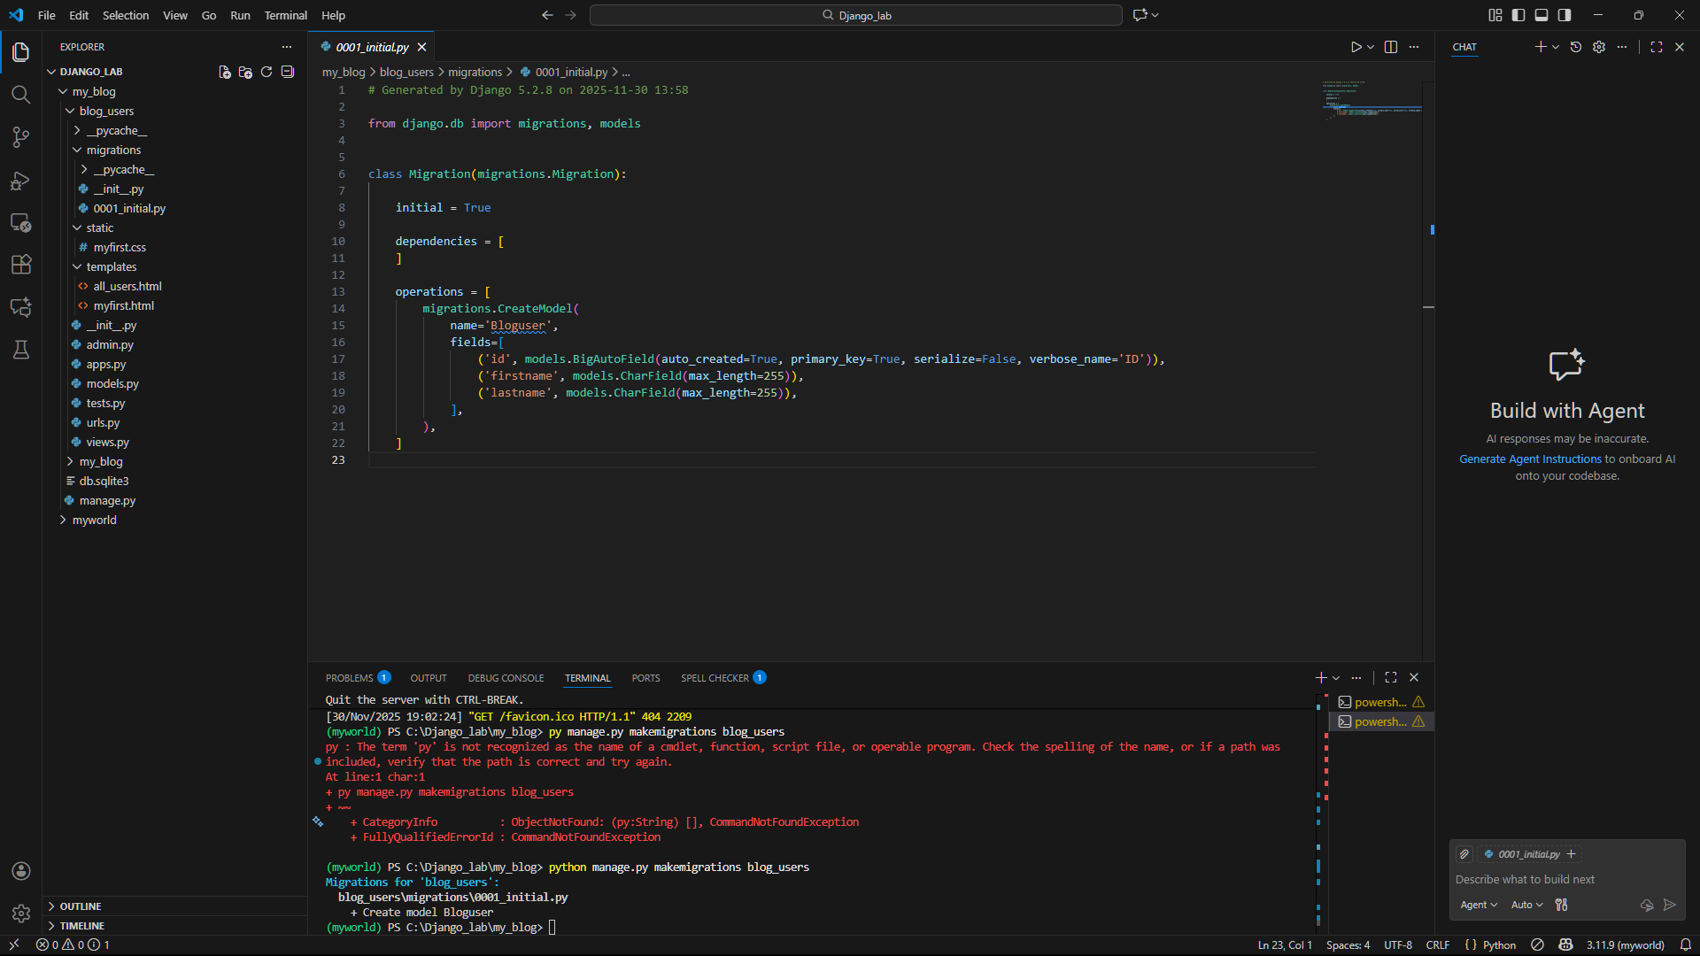
Terminal with 0001_initial.py created.
- Apply migrations:
(myworld)
- python manage.py migrate
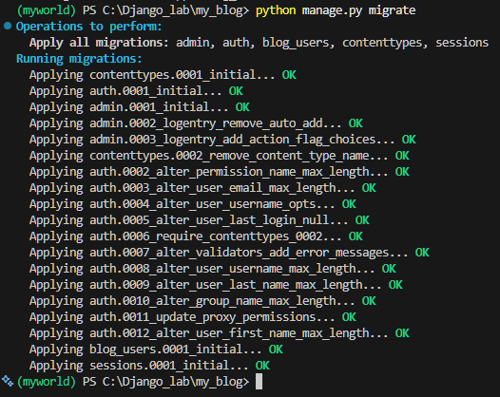
terminal showing migrations applied.

3. Add records in Django shell:
(myworld)
- python manage.py shell
Inside shell:
from blog_users.models import Bloguser
bloguser = Bloguser(firstname='Amit', lastname='Roy')
bloguser.save()
b1 = Bloguser(firstname='Ritesh', lastname='Roy')
b2 = Bloguser(firstname='Soham', lastname='Sarkar')
b3 = Bloguser(firstname='Sourav', lastname='Das')
for b in (b1, b2, b3): b.save()
Bloguser.objects.all().values()
Exit Django Shell:
- exit()
- Run server and view list:
(myworld)
- python manage.py runserver
Open: http://127.0.0.1:8000/all-users/ — you should see the users.
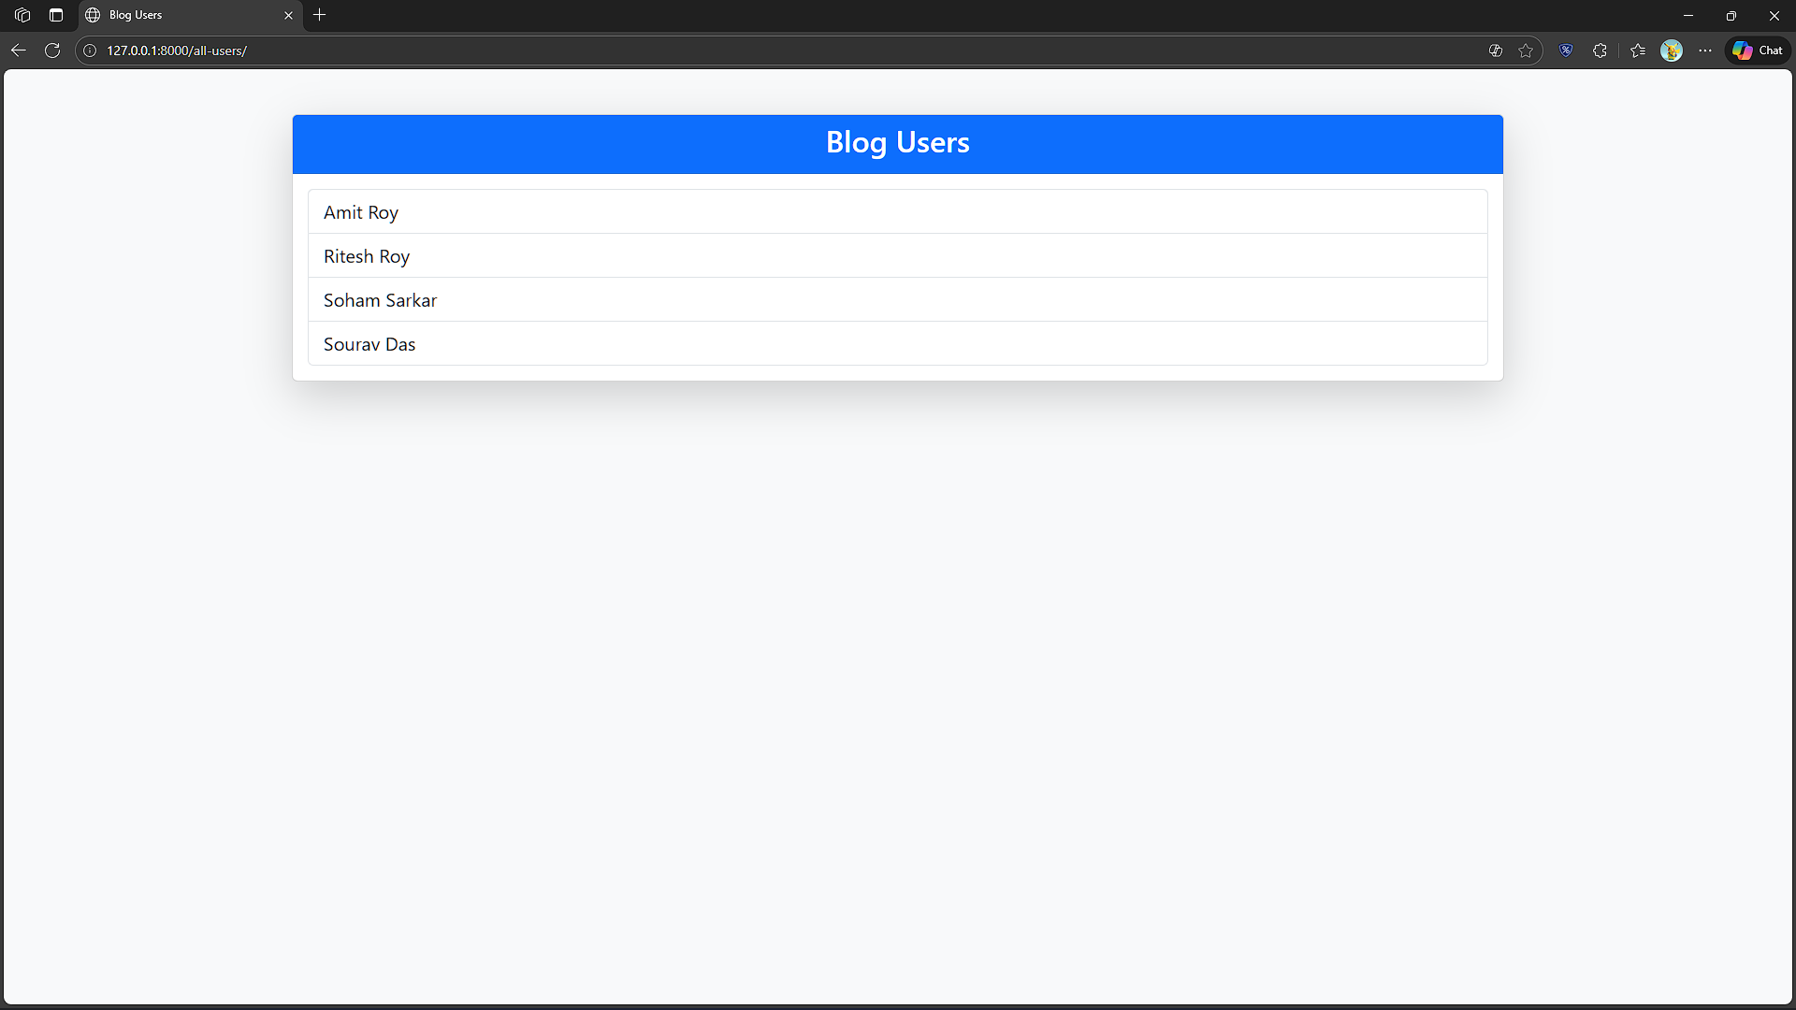
Browser showing Blog Users list.

Add data from Admin

1. Register the model in admin (one-time)
Edit blog_users/admin.py:
from django.contrib import admin
from .models import Bloguser
admin.site.register(Bloguser)

2. Create a superuser to access admin (one-time)
In terminal :
- python manage.py createsuperuser
Enter username, email, password.

3. Run the server and open admin
- python manage.py runserver
Open browser: http://127.0.0.1:8000/admin/
- Login with the superuser credentials.
- Click Blogusers → Add Bloguser → fill firstname and lastname → Save.
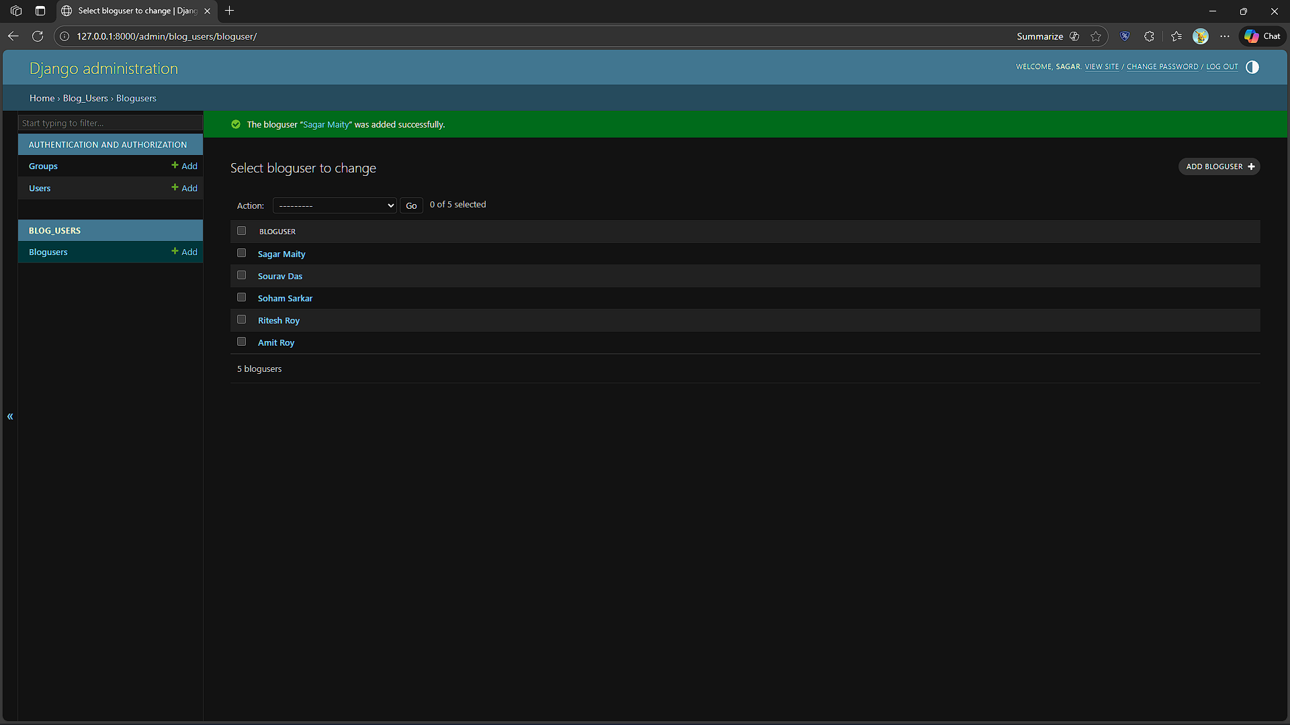
After saving.

